A2_Preprocess.Rmd / Heat-Related Mortality / Exposure Response

Hans-Aloys Wischmann, Institute for Public Health, Charité - Universitätsmedizin Berlin

Written: 2023-04-12 to 2023-08-31 / Totally revised: 2024-11-07 to 2025-07-04 / Executed: 2025-07-04

# Prerequisites and Expected Execution Time

Prerequisites: A0_Download.sh successfully completed, A1_Parameters.R reviewed and confirmed

Expected execution time: About 4 minutes (12/24 physical/logical cores @ 5.7 GHz, 32 GB RAM)

# Geography

Acknowledgement for administrative boundaries: © EuroGeographics for the administrative boundaries.

Populations are only available separately for England and Wales, so that they need to be treated as separate countries for the pre-processing.

Excluded Regions

| NUTS | Region |
| --- | --- |
| ES63 | Ciudad de Ceuta |
| ES64 | Ciudad de Melilla |
| ES70 | Canarias |
| FRY1 | Guadeloupe |
| FRY2 | Martinique |
| FRY3 | Guyane |
| FRY4 | La Réunion |
| FRY5 | Mayotte |
| PT20 | Região Autónoma dos Açores |
| PT30 | Região Autónoma da Madeira |
| UKM | Scotland |
| UKN | Northern Ireland |

Number of Regions per Country

| Country | n |
| --- | --- |
| Austria | 9 |
| Belgium | 11 |
| England.Wales | 10 |
| France | 22 |
| Germany | 16 |
| Italy | 21 |
| Netherlands | 12 |
| Portugal | 5 |
| Spain | 16 |
| Switzerland | 7 |
| Total, N=10 | 129 |

# Populations: Eurostat

© European Union, 1995-2024

Unless otherwise indicated (e.g. in individual copyright notices), content owned by the EU on this website is licensed under the Creative Commons Attribution 4.0 International (CC BY 4.0) licence. This means that reuse is allowed, provided appropriate credit is given and changes are indicated

Missing n_pop Data for Males from Total - Females

| Region | Country | Sex | Age | Year | n_pop |
| --- | --- | --- | --- | --- | --- |
| ES21 | Spain | F | 45-49 | 2,001 | 72,601 |
| ES21 | Spain | M | 45-49 | 2,001 | 71,911 |

# Populations: ONS

ONS Crown Copyright Reserved [from Nomis on 25 June 2024]

# Populations: Aggregate and Visualize

[1] "Populations.Rdata (is.na = 0)"

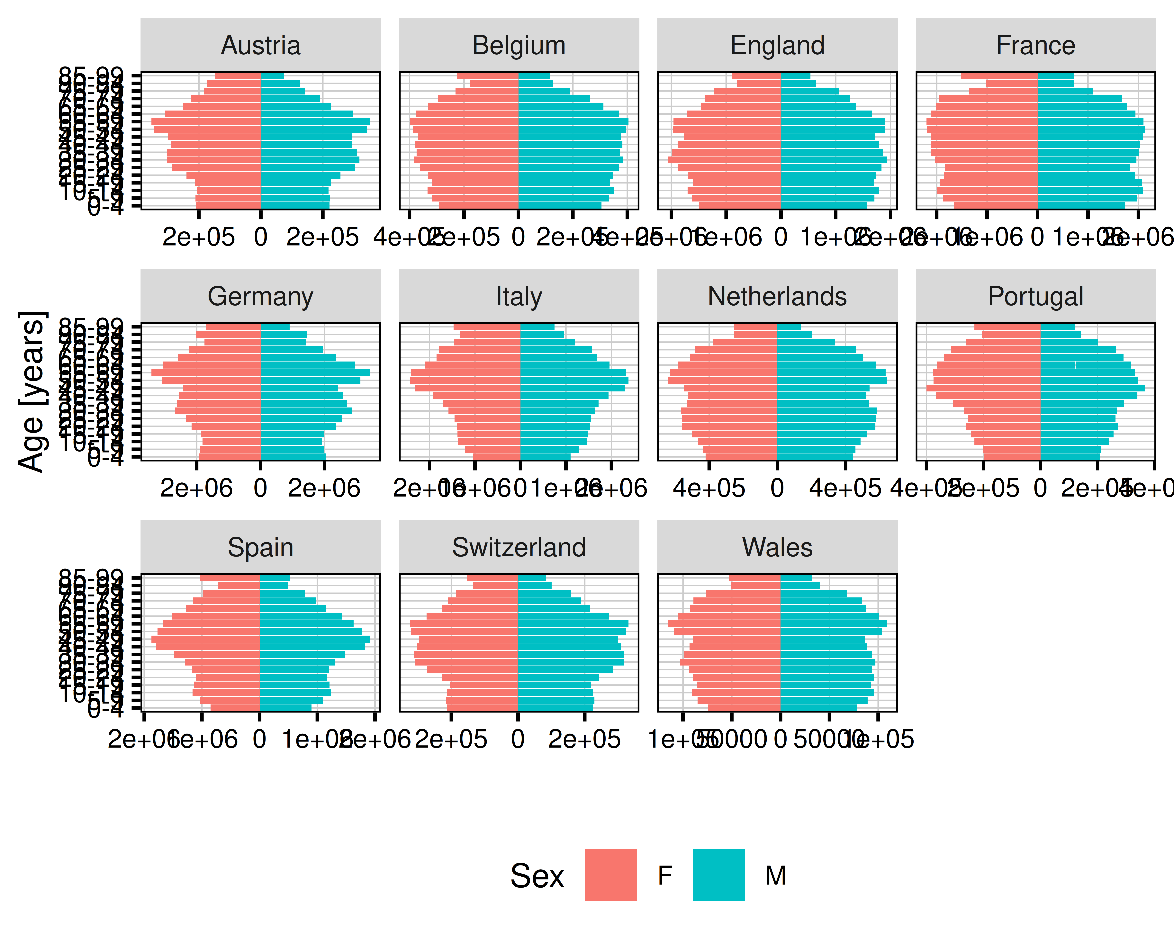

[1] "Figure_X1: Population Data 2022, © European Union, 1995-2024 and ONS, 2024"

# Deaths (Eurostat)

© European Union, 1995-2024

Unless otherwise indicated (e.g. in individual copyright notices), content owned by the EU on this website is licensed under the Creative Commons Attribution 4.0 International (CC BY 4.0) licence. This means that reuse is allowed, provided appropriate credit is given and changes are indicated

# Deaths (DESTATIS)

© Statistisches Bundesamt (Destatis), 2024

Vervielfältigung und Verbreitung, auch auszugsweise, mit Quellenangabe gestattet.

# Deaths (ONS, Commissioned)

# Deaths (ONS, Provisional 2023)

# Deaths (INSEE)

# Deaths: Aggregate

[1] "Deaths.Rdata (is.na = 0)"

# Populations: 1km x 1km grid, accumulate onto 0.1 x 0.1 degree grid (inside regions)

© Eurostat, 1995 - today

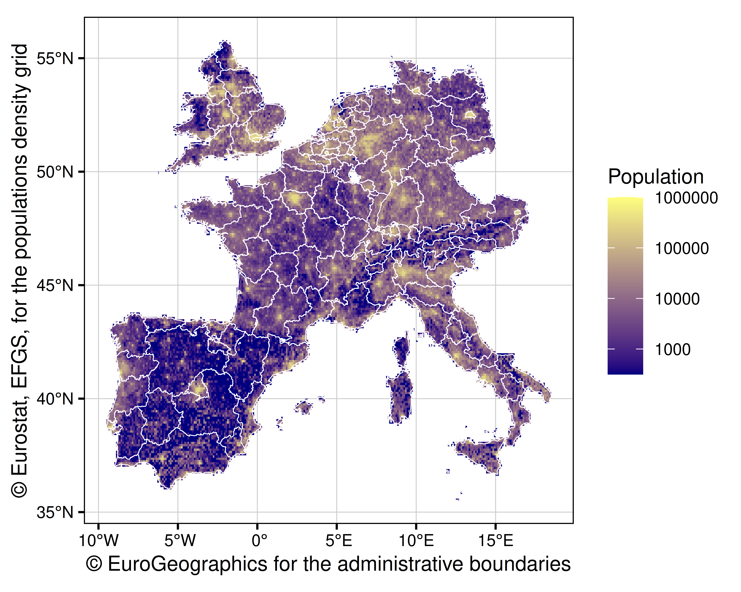

[1] "Figure_X2: Population 2018 on (0.1 ° x 0.1 °) Grid"

# Daily Mean Temperatures

Acknowledgment: We acknowledge the E-OBS dataset from the EU-FP6 project UERRA (<https://www.uerra.eu>) and the Copernicus Climate Change Service, and the data providers in the ECA&D project (<https://www.ecad.eu>)

Citation: Cornes, R., G. van der Schrier, E.J.M. van den Besselaar, and P.D. Jones. 2018: An Ensemble Version of the E-OBS Temperature and Precipitation Datasets, J. Geophys. Res. Atmos., 123. <doi:10.1029/2017JD028200>

[1] "Temperatures.Rdata (is.na = 3225)"

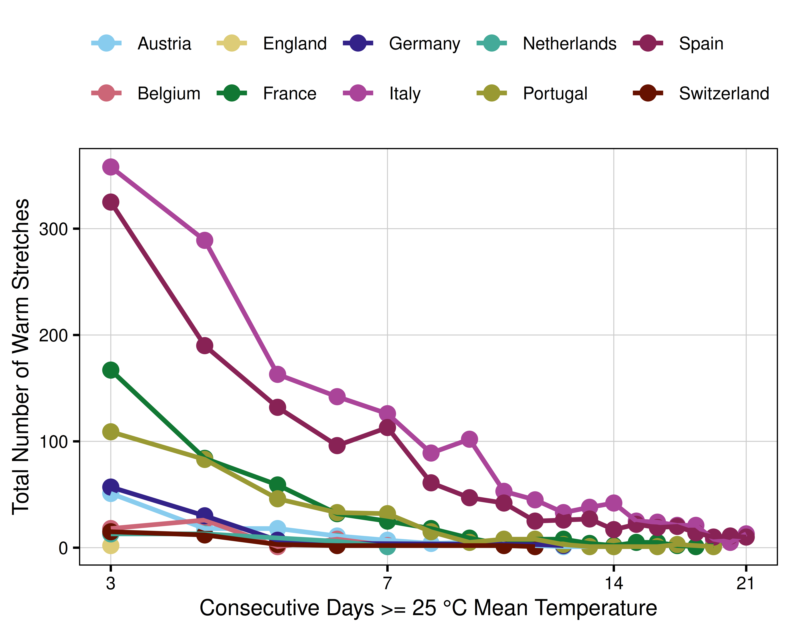

[1] "Figure_X3: Hot Stretches by Region (2000-01-01 to 2024-12-31)"

# Temperature Plots

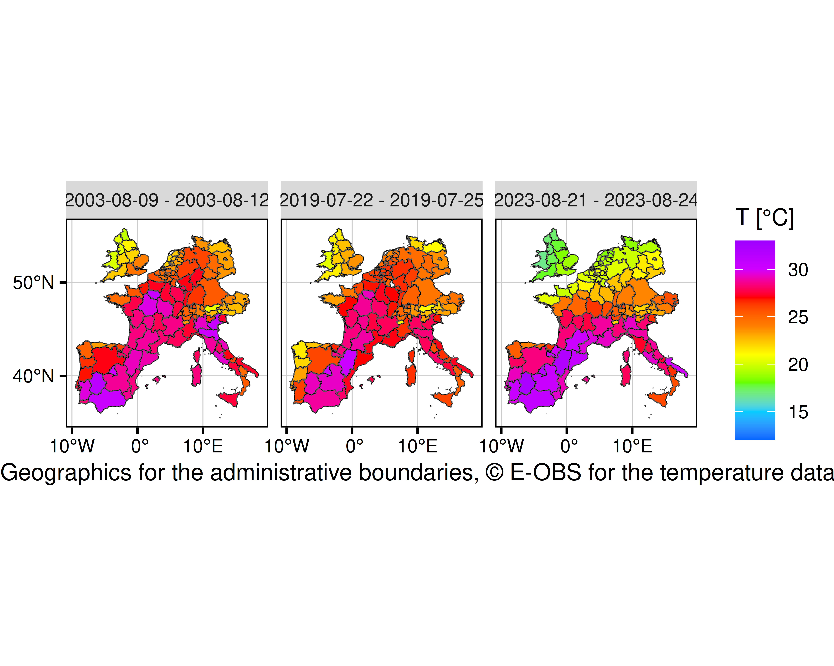

[1] "Figure_S4: Average Temperatures"

# Outcome Plots: Deaths (Absolute, Standardized)

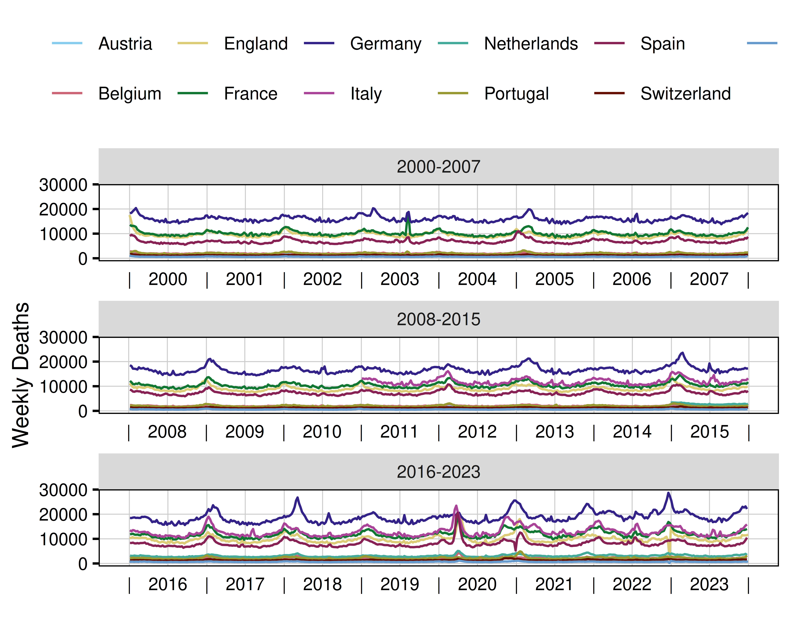

[1] "Figure_X4: Deaths (Observed)"

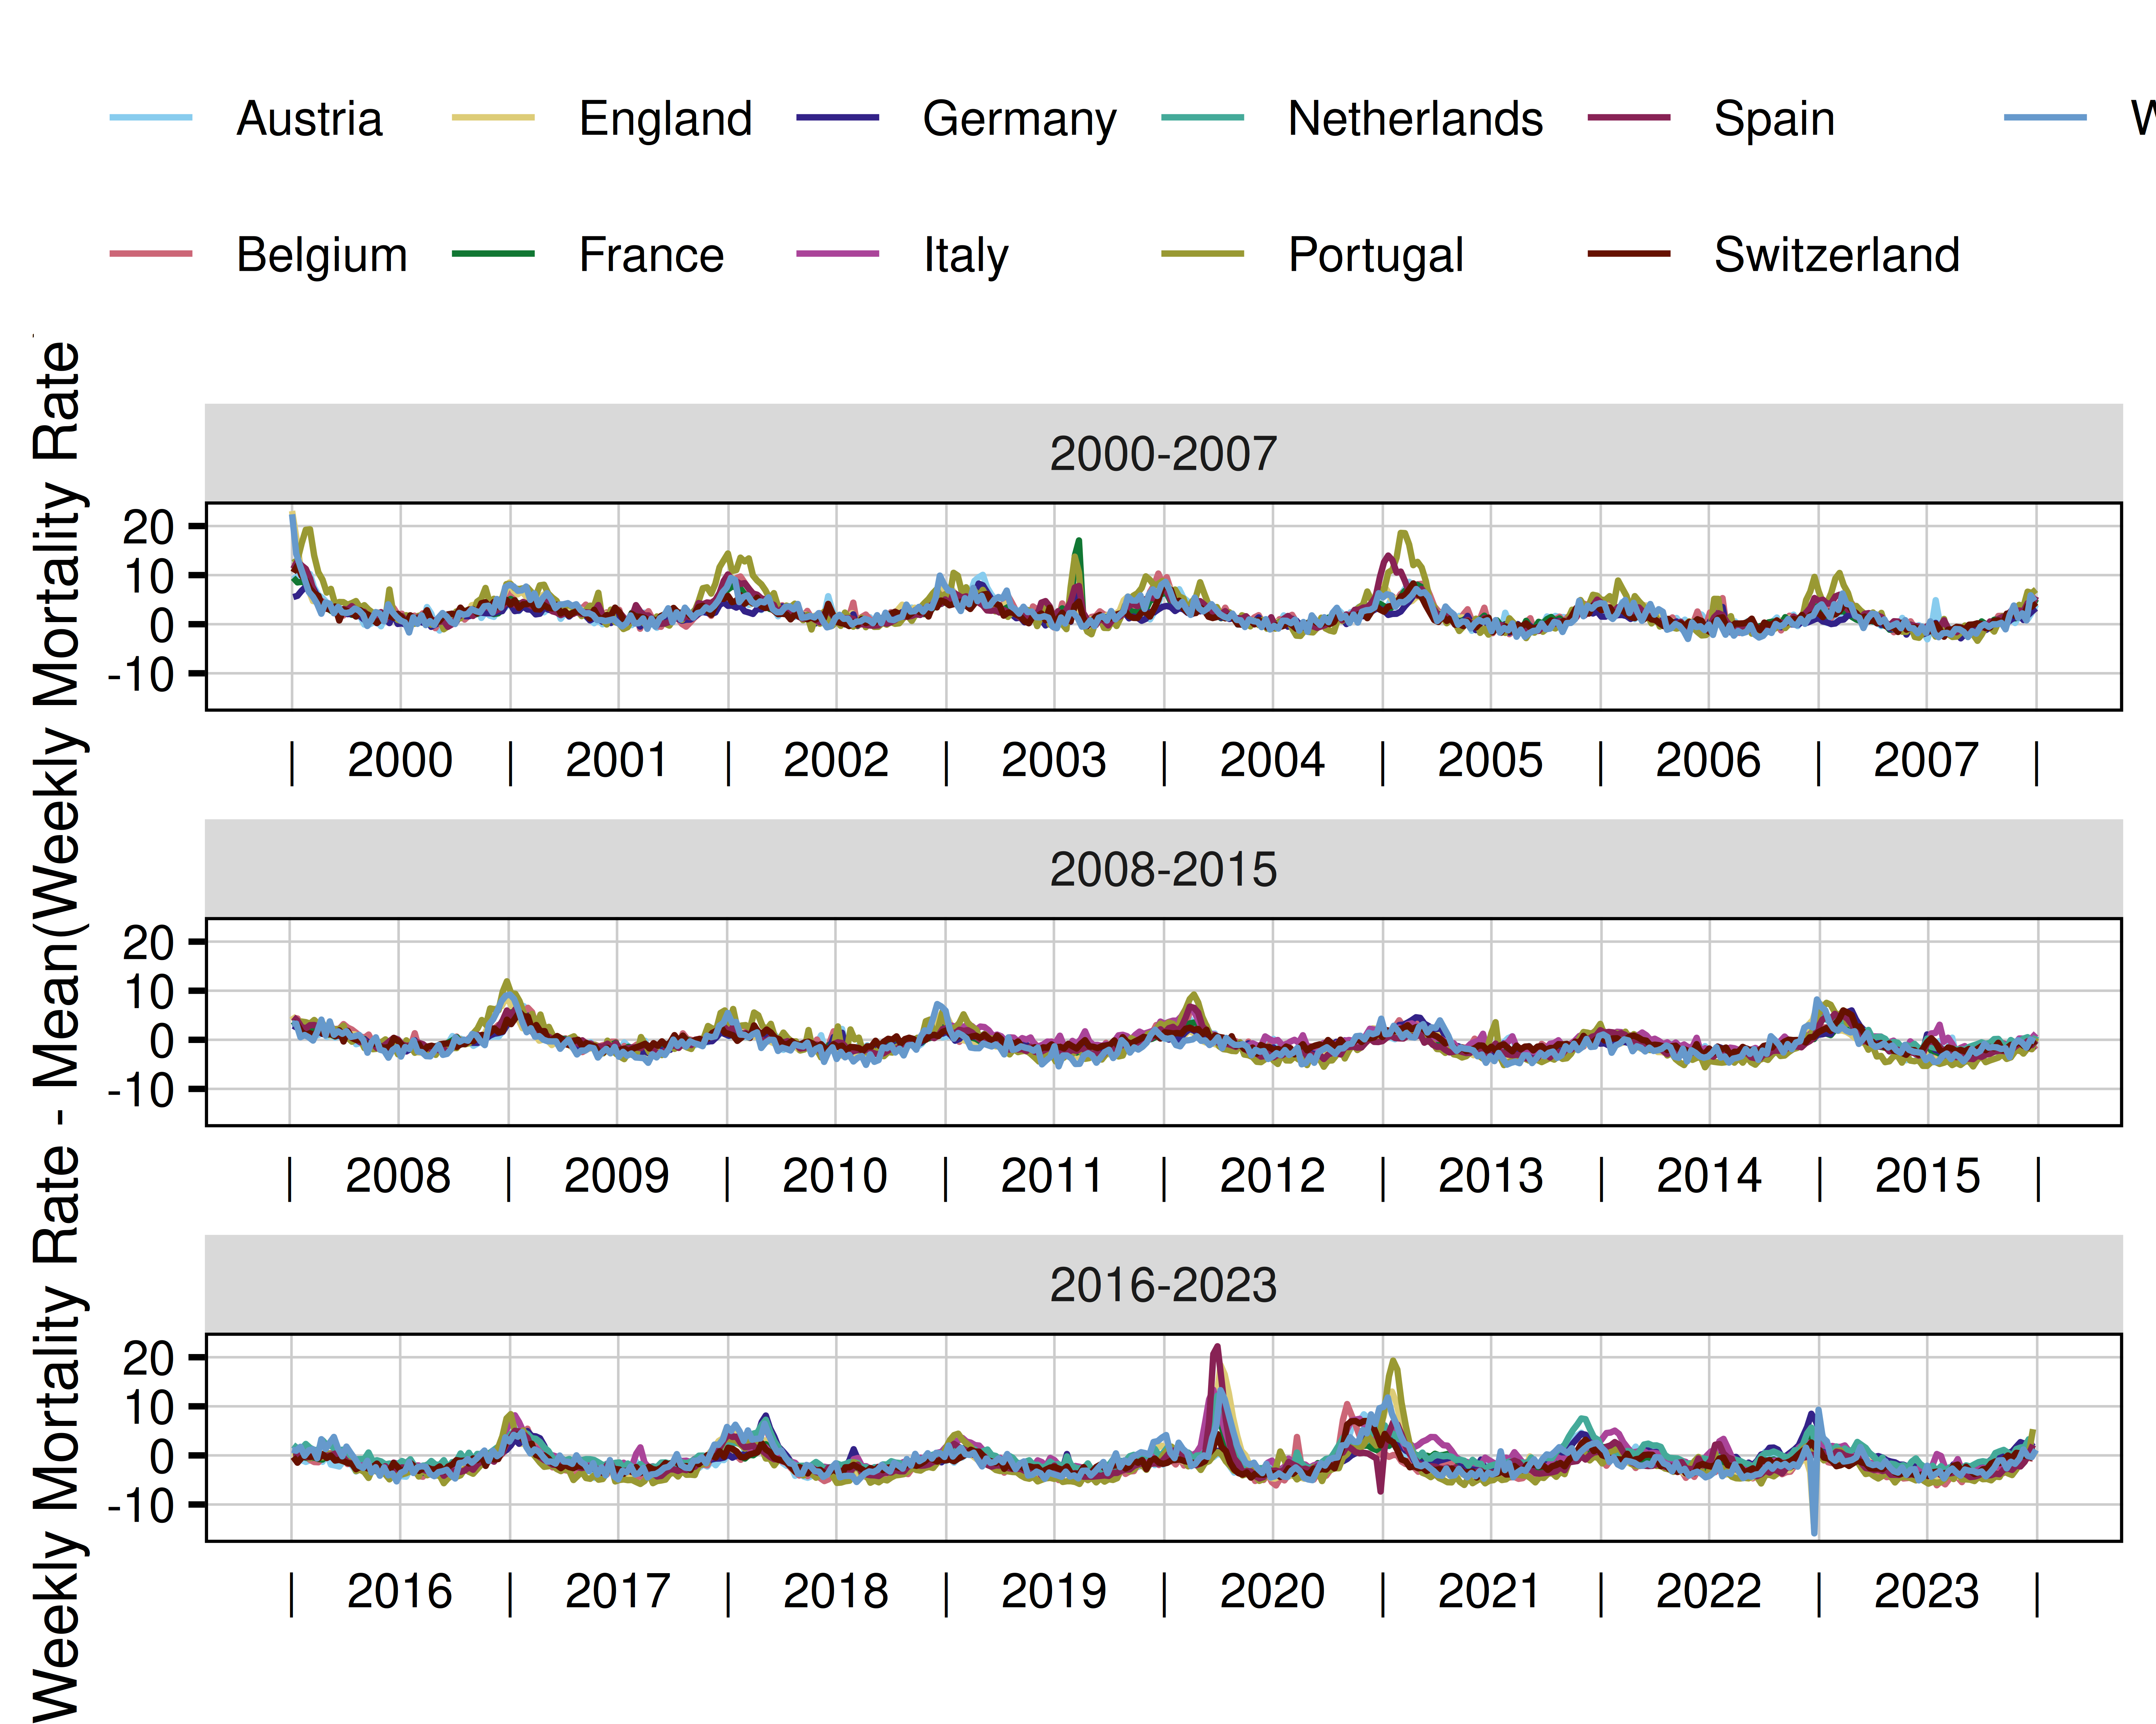

[1] "Figure_X5: Deaths (EU27 Standard Population)"

# Exposure Response (Raw)

Exposure response is shown by country, as the sum over incremental deaths across the regions, by temperature bracket (integer degree +/- 0.5 degrees), for pre-pandemic years, for summer weeks.

Warning: `is.ggproto()` was deprecated in ggplot2 3.5.2.  
ℹ Please use `is_ggproto()` instead.  
This warning is displayed once every 8 hours.  
Call `lifecycle::last_lifecycle_warnings()` to see where this warning was  
generated.

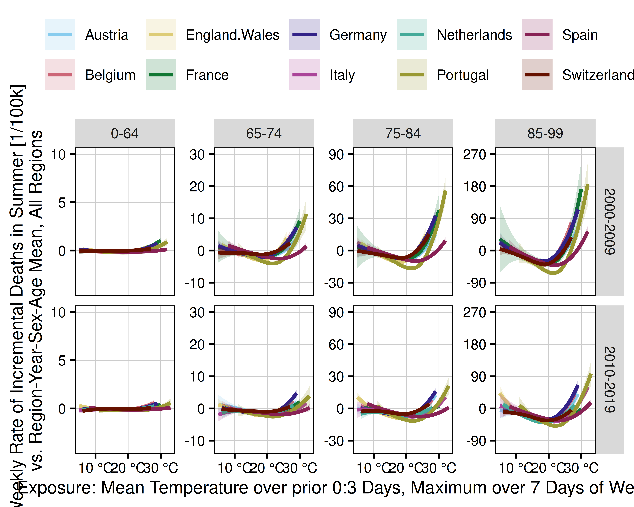

[1] "Figure_1: Raw Exposure Response Curves (Summer), Incremental Deaths"

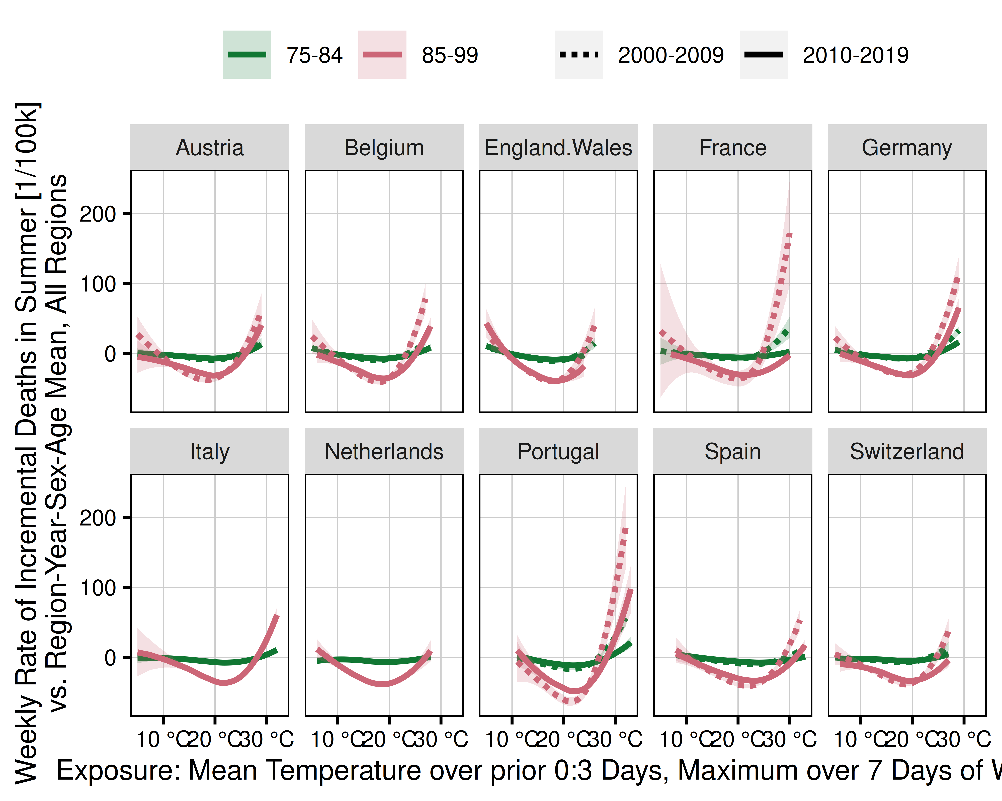

[1] "Figure_2: Raw Exposure Response Curves (Summer), Incremental Deaths, 74-84 and 85+ Years"

# Combine Required Data

Merge tables of deaths and populations, combine England and Wales into England.Wales for the main analysis, append (lagged) temperature exposures, filter on summer weeks.

# Done

user system elapsed   
303.484 45.248 250.859

$citation  
To cite RStudio in publications use:  
  
 Posit team (2025). RStudio: Integrated Development Environment for R.  
 Posit Software, PBC, Boston, MA. URL http://www.posit.co/.  
  
A BibTeX entry for LaTeX users is  
  
 @Manual{,  
 title = {RStudio: Integrated Development Environment for R},  
 author = {{Posit team}},  
 organization = {Posit Software, PBC},  
 address = {Boston, MA},  
 year = {2025},  
 url = {http://www.posit.co/},  
 }  
  
$mode  
[1] "desktop"  
  
$version  
[1] '2025.5.1.513'  
  
$long_version  
[1] "2025.05.1+513"  
  
$release_name  
[1] "Mariposa Orchid"

R version 4.5.1 (2025-06-13)  
Platform: x86_64-pc-linux-gnu  
Running under: Ubuntu 24.04.2 LTS  
  
Matrix products: default  
BLAS: /usr/lib/x86_64-linux-gnu/openblas-pthread/libblas.so.3   
LAPACK: /usr/lib/x86_64-linux-gnu/openblas-pthread/libopenblasp-r0.3.26.so; LAPACK version 3.12.0  
  
locale:  
 [1] LC_CTYPE=en_US.UTF-8 LC_NUMERIC=C   
 [3] LC_TIME=en_US.UTF-8 LC_COLLATE=en_US.UTF-8   
 [5] LC_MONETARY=en_US.UTF-8 LC_MESSAGES=en_US.UTF-8   
 [7] LC_PAPER=de_DE.UTF-8 LC_NAME=C   
 [9] LC_ADDRESS=C LC_TELEPHONE=C   
[11] LC_MEASUREMENT=de_DE.UTF-8 LC_IDENTIFICATION=C   
  
time zone: Europe/Berlin  
tzcode source: system (glibc)  
  
attached base packages:  
[1] parallel stats graphics grDevices utils datasets methods   
[8] base   
  
other attached packages:  
 [1] ggh4x_0.3.0 ncdf4_1.24 readxl_1.4.5   
 [4] sf_1.0-21 ISOweek_0.6-2 RhpcBLASctl_0.23-42  
 [7] doParallel_1.0.17 iterators_1.0.14 foreach_1.5.2   
[10] flextable_0.9.8 lubridate_1.9.4 forcats_1.0.0   
[13] stringr_1.5.1 dplyr_1.1.4 purrr_1.0.4   
[16] readr_2.1.5 tidyr_1.3.1 tibble_3.2.1   
[19] ggplot2_3.5.2 tidyverse_2.0.0   
  
loaded via a namespace (and not attached):  
 [1] tidyselect_1.2.1 farver_2.1.2 fastmap_1.2.0   
 [4] fontquiver_0.2.1 digest_0.6.37 timechange_0.3.0   
 [7] lifecycle_1.0.4 magrittr_2.0.3 compiler_4.5.1   
[10] rlang_1.1.6 tools_4.5.1 yaml_2.3.10   
[13] data.table_1.17.2 knitr_1.50 askpass_1.2.1   
[16] labeling_0.4.3 classInt_0.4-11 xml2_1.3.8   
[19] RColorBrewer_1.1-3 KernSmooth_2.23-26 withr_3.0.2   
[22] grid_4.5.1 gdtools_0.4.2 e1071_1.7-16   
[25] scales_1.4.0 cli_3.6.5 crayon_1.5.3   
[28] rmarkdown_2.29 officedown_0.4.1 ragg_1.4.0   
[31] generics_0.1.4 rstudioapi_0.17.1 tzdb_0.5.0   
[34] DBI_1.2.3 cachem_1.1.0 proxy_0.4-27   
[37] splines_4.5.1 s2_1.1.8 cellranger_1.1.0   
[40] vctrs_0.6.5 Matrix_1.7-3 fontBitstreamVera_0.1.1  
[43] hms_1.1.3 systemfonts_1.2.3 units_0.8-7   
[46] glue_1.8.0 codetools_0.2-20 stringi_1.8.7   
[49] gtable_0.3.6 pillar_1.10.2 htmltools_0.5.8.1   
[52] openssl_2.3.2 R6_2.6.1 wk_0.9.4   
[55] textshaping_1.0.1 rvg_0.3.5 lattice_0.22-5   
[58] evaluate_1.0.3 memoise_2.0.1 fontLiberation_0.1.0   
[61] class_7.3-23 Rcpp_1.0.14 zip_2.3.3   
[64] uuid_1.2-1 nlme_3.1-168 mgcv_1.9-1   
[67] officer_0.6.9 xfun_0.52 pkgconfig_2.0.3